ContactManagement_Verify Contact notes _Instance44_12-Jul-2018_05-06-43_AM_EnterTextAction.png

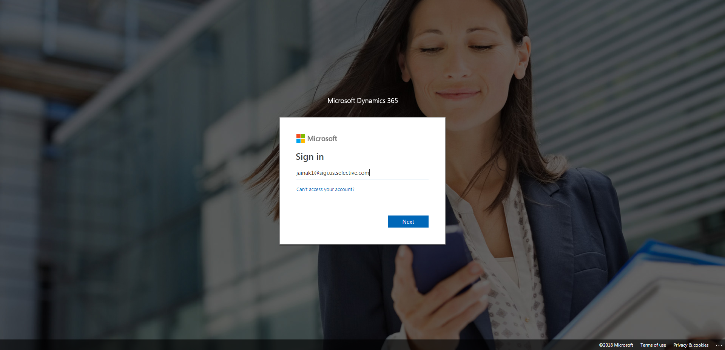

ContactManagement_Verify Contact notes _Instance44_12-Jul-2018_05-08-15_AM_Validatingcontactentitynavigation.png

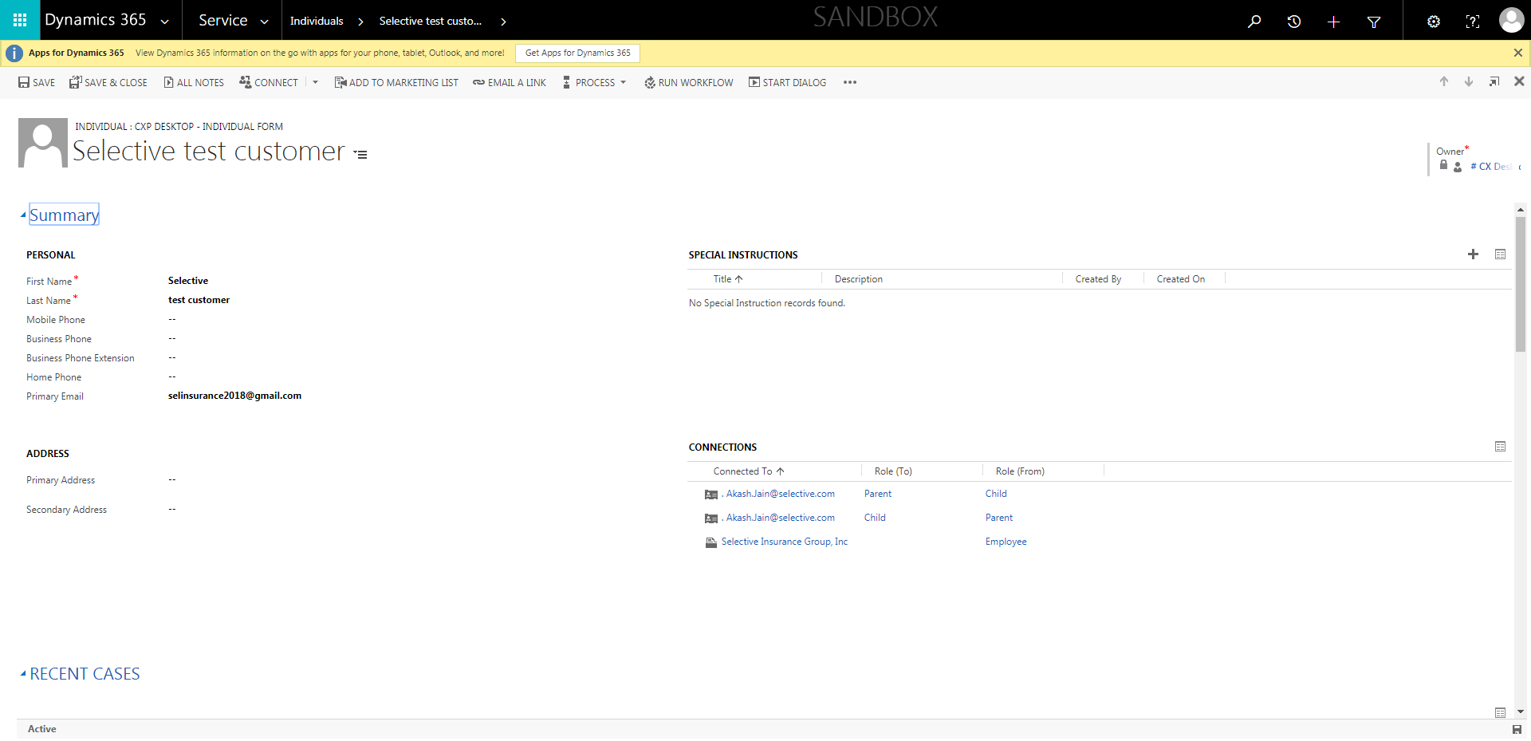

ContactManagement_Verify Contact notes _Instance44_12-Jul-2018_05-08-25_AM_VerifyingAllNotesofanindividual.png

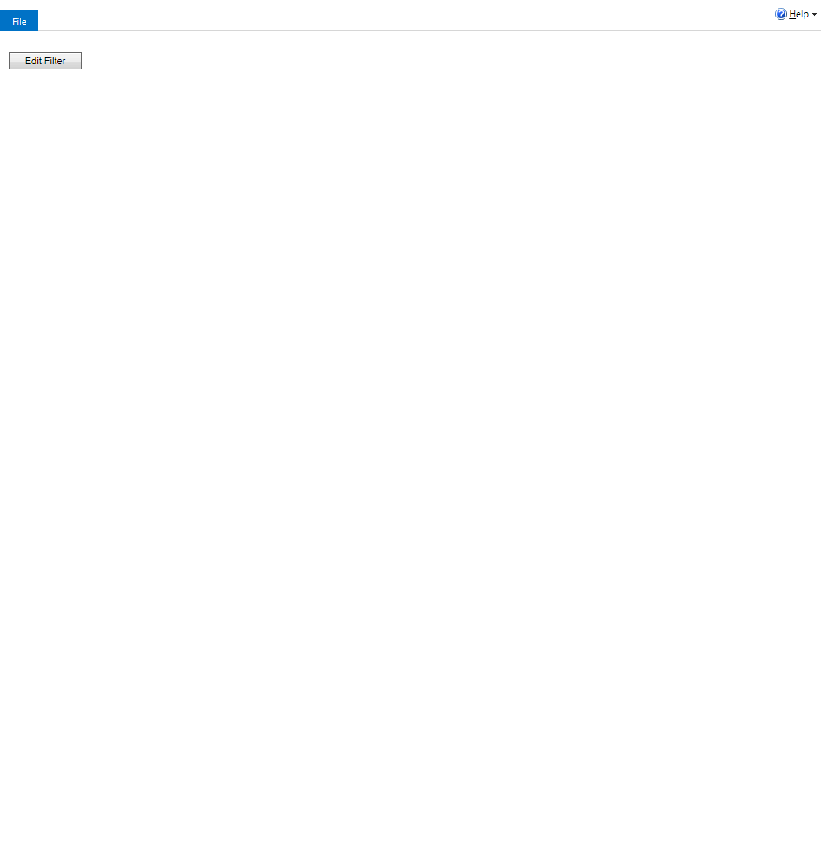

ContactManagement_Verify Contact notes _Instance44_12-Jul-2018_05-06-41_AM_MouseClickActiononStaleElement.png



ContactManagement_Verify Contact notes _Instance44_12-Jul-2018_05-06-45_AM_MouseClickActiononStaleElement.png

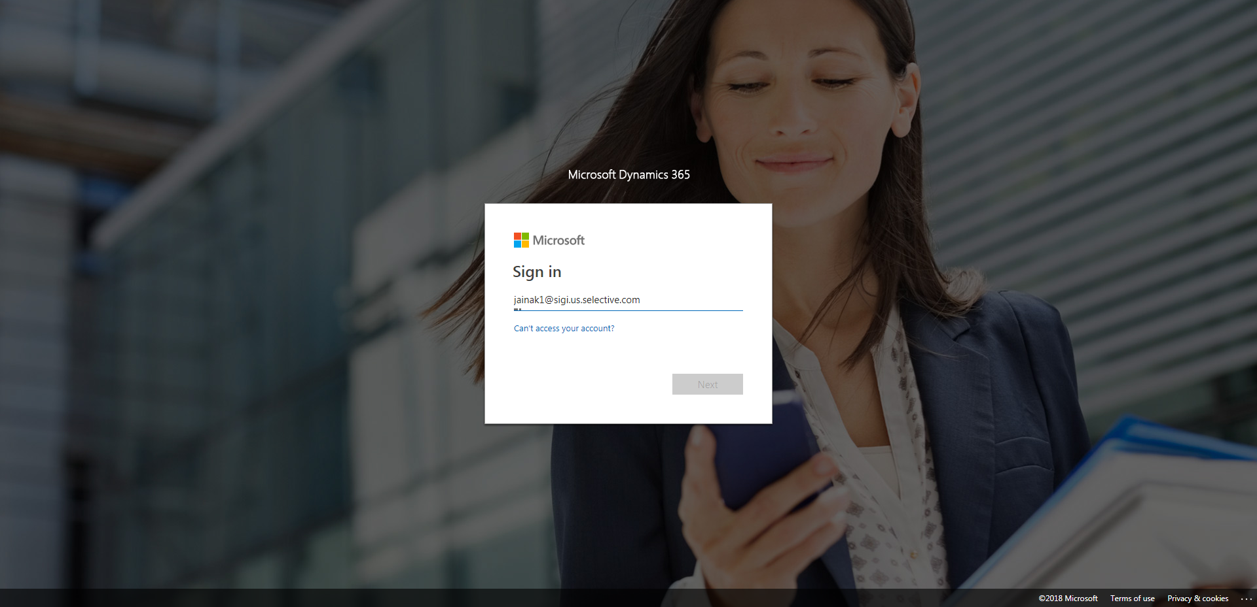

ContactManagement_Verify Contact notes _Instance44_12-Jul-2018_05-07-08_AM_SingleSignOn.png

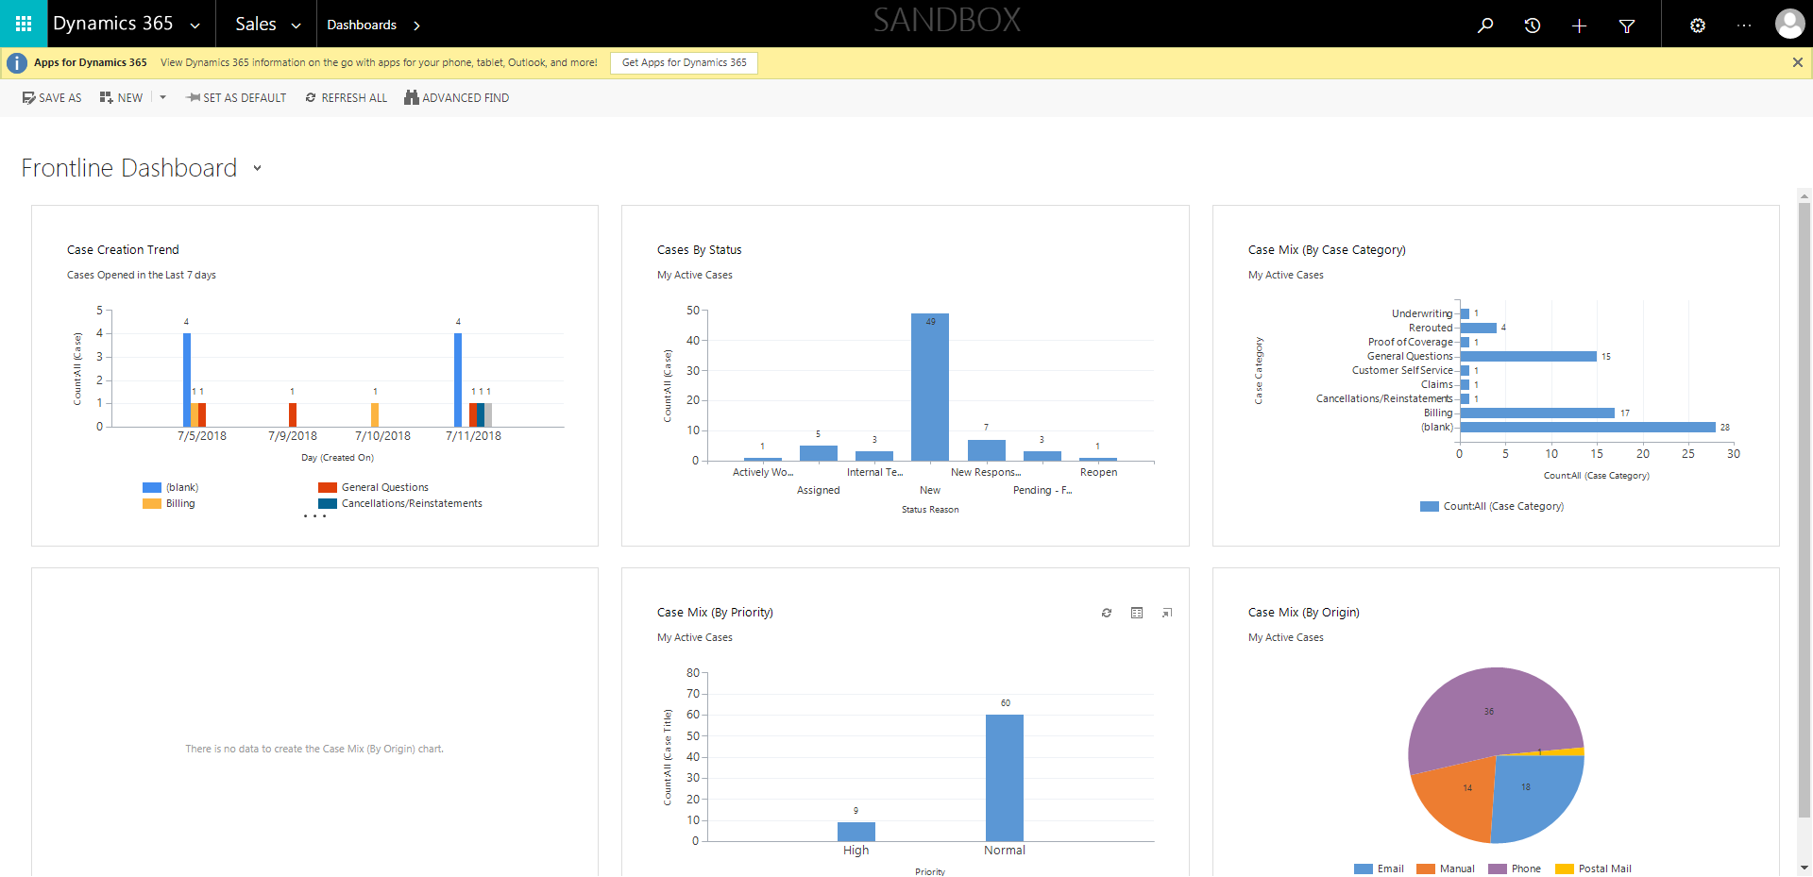

ContactManagement_Verify Contact notes _Instance44_12-Jul-2018_05-07-03_AM_SingleSignOn.png

